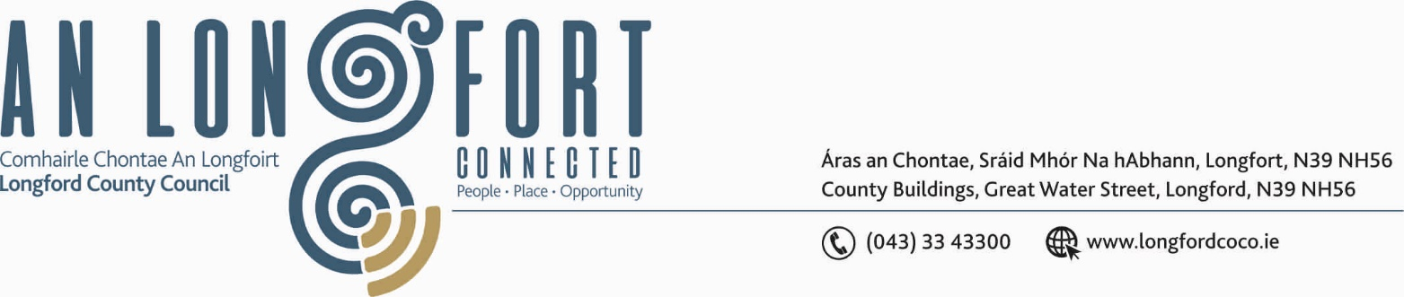

BALLYMAHON MUNICIPAL DISTRICT

3rd December 2019.

To: Each Member of Ballymahon Municipal District.

Dear Member,

You are requested to attend Meeting of Ballymahon Municipal District to be held in Ballymahon Community Library, on Monday 9th December 2019 at
4.00 p.m. to transact business, as set out on the Agenda hereunder.

Yours sincerely,
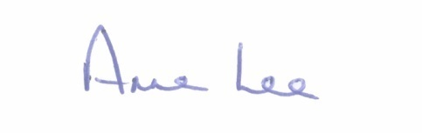

_______________
Anne Lee,
Meetings Administrator.

AGENDA

Prayer before meeting.

1. Confirmation of Minutes of Ballymahon Municipal District Meetings held on the 26th September and 24th October 2019 - copy enclosed.

2. Matters arising from Minutes.

3. Declaration of Interest by Members.

4. Management Report - to follow.

5. Community Grant Support Scheme.

6. Provision of EV Charging Point in Edgeworthstown - documentation attached.

7. Consideration and approval to the Taking in Charge of “Sli na Moinear”,
Moydow, Co. Longford – circulated on the 8th November 2019.

8. Notices of Motions submitted by Councillors, as listed hereunder –

Councillor Pat O’Toole.

“I request Longford County Council to consider erecting a plaque or commemorative stone in Cloncallow Cemetery given it’s association with the famine of 1847 and the former Ballymahon Workhouse which opened in April 1850. The cemetery committee have carried out major improvement works there over the past number of years and feel that a plaque or stone would be fitting memorial to all those from the famine era who are interred there.”

“To ask Longford County Council in conjunction with Gas Networks Ireland to consider in 2020 extending the natural gas pipeline from Nally’s Filling Station to the Vocational School which would give both the Vocational School and St. Matthew’s Primary School the opportunity to connect to the network.”

Councillor Paul Ross.

"That all the houses in the estate of St Matthews Park Ballymahon have new energy efficient windows and doors fitted as a matter of urgency ".

“That a barrier be put on the footpath on the R392 at Creevaghbeg , Ballymahon from the Water tower down to the N55 to prevent traffic mounting the footpath on this dangerous bend".

Councillor Mick Cahill.

“That the Council move the Roads Programme meeting for the adoption of the roads programme from March to January thereby ensuring that propriety work on these roads is not carried out in the hedge cutting season.”

“That the council agree a schedule of hedge cutting of junctions on Local, Regional and National Roads to be carried out before the end of the hedge cutting season and the grass cut at these junctions also midsummer.”
“That Longford County Council removes the hedge on the first corner between the Blue Doors (T-Junction) and Carrickboy at Deerpark on the R393 in the interest of road safety.”

Councillor Mark Casey.

“That this Council repairs and replaces the footpath along the Rathcline road in Lanesboro, as it is gone into disrepair and is now dangerous for the user.”

“That the road to Fermoyle School is included in the roads salting program as it is a very sheltered road and is used by over 100 cars every morning.”

“That the footpath on the corner beside the Church in Lanesboro is repaired as it has become dangerous.”

Councillor Gerard Farrell.

“I call on Longford County Council Roads Department to put in signage and lights approaching the children's crossing in Lanesboro because it is dangerous.”

“I call on Longford County Council Roads Department to look at tidying up the compound on the Killashee to Lanesboro road where the road is wide at Willis house as it doesn't seem to be used anymore. The fence is all broken down and it is an eye sore.”

“I call on Longford County Council Roads Department to seek funding to replace footpaths on the Rathcline road in Lanesboro.”



